Review: rate of reactions & equilibrium. Name____________________________Period______Date:______
- Mention three factors affecting reaction rates. Explain how and why one of the factors affects the reaction rate.
- In the diagram, identify the exothermic reaction and the endothermic reaction; then, label: reactants, products, activation energy, energy released, energy absorbed.
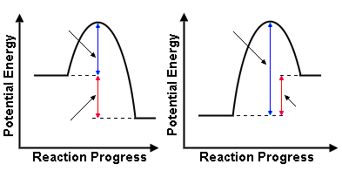
- Write the expression of the equilibrium constants for the following exothermic reactions:
a) 4NH₃(g) + 5O₂(g) 4NO(g) + 6H₂O(g)
b) H₂(g) + I₂(g) 2HI(g)
3.1 How the equilibrium position of this reaction affected by the following changes?
3.1a By increasing the concentration of NH₃ in a) or I₂ in b)
3.1b By increasing the pressure over those systems.
3.1c Lowering temperature.
3.1d Adding water vapor in a), or adding iodine gas in b)
4. The mixture of hydrogen and iodine at equilibrium consists of 0.13 mol of hydrogen and iodine, and 0.23 mol of hydrogen iodide in a one liter flask. Calculate Keq.
H₂(g) + I₂(g) 2HI(g)
- In problem 4; does the mixture at equilibrium consists mainly of reactants or products? Explain.
- Suppose the following system reaches equilibrium: 4NH₃(g) + 5O₂(g) 4NO(g) + 6H₂O(g) If the concentrations of the substances are, ammonia, 0.13 mol/L; oxygen, 0.1 mol/L, nitrogen monoxice, 0.6 mol/L and water vapor 0.9 mol/L, calcule K_{eq}.
- At a given temperature, the equilibrium constant for the following reaction is 3.6
2NO₂(g) ↔N₂O₄(g) Given that the conc of N₂O₄(g) is 0.66 mol/L, what is the equilibrium conc of NO₂?
- Hydrogen iodide decomposes as follows: 2HI(g) ↔ H₂(g) + I₂(g), the Keq at 500 ºC is 0.025. If in a 1 liter of the mixture contains 0.50 mol of H₂, what is the equilibrium concentration of HI (g)?

